Facebook
Locate privacy settings:
- Log in to Facebook
- Click in the upper-right corner of any Facebook page
- Select Settings from the dropdown menu
- Select Privacy on the left
- Click a setting (ex: Who can see your future posts?) to edit it

You can also quickly view and adjust some of the most used privacy settings and tools from your Privacy Shortcuts at the top right of any Facebook page.

When I post something, how do I choose who can see it?
You'll find an audience selector tool most places you share status updates, photos and other things you post. Click the tool and select who you want to share something with.
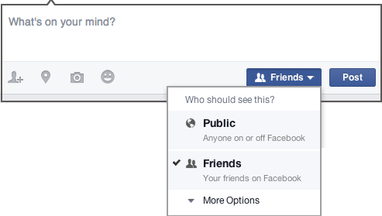

The tool remembers the audience you shared with the last time you posted something and uses the same audience when you share again unless you change it.
The audience selector also appears alongside things you've already shared, so it's clear who can see each post. After you've shared a post, you have the option to change who it's shared with. If you want to change the audience of a post after you've shared it, click the audience selector and select a new audience.
Remember, when you post to another person's Timeline, that person controls what audience can view the post. Additionally, anyone who gets tagged in a post may see it, along with their friends.

How to block someone
- Click "account" in the upper right corner of your Facebook page.
- Select "privacy settings."
- Under "block lists" at the bottom centre of the page, click "edit your lists."
- At the top, under "block users," add the name or e-mail address of the person you'd like to block.
- Click "block."

How to make your profile unsearchable to everyone
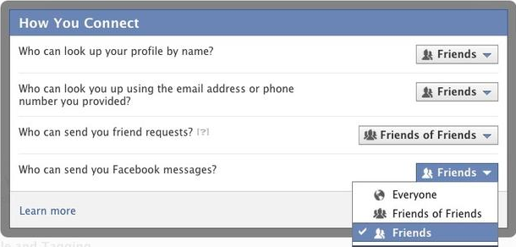
Facebook profiles are available to everyone so users can view your profile, contact you or send friend requests but you can make your profile unsearchable so no-one can find you.
- First go to your name
- Click the down arrow next to the ‘Home’ link and then select ‘Privacy Settings’ from the context menu.
- Click the ‘Edit Settings’ link located next to the ‘How you Connect’ section.
- Click the drop-down options next to all available questions, such as who can find your profile by name, by email address and/or phone number. Select the ‘Friends’ option, which prevents strangers and anyone outside of your existing friend list from finding you.
- Click ‘Done’ to apply all changes.

